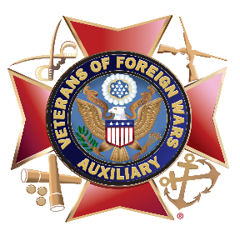
Official National VFW “Buddy”® Poppy
Display Contest, Unofficial
“Buddy”® Poppy Display Contest & VFW National “Buddy”® Poppy Awards

VFW “Buddy”® Poppy Display Contest
This is an official VFW National contest. The VFW National “Buddy”® Poppy Display Contest takes place annually at National Convention. Displays are judged in three (3) categories.

Category 1. Public Promotion of Poppy Campaign

Category 2. Memorial or Inspirational Displays

Category 3. Artistic or Decorative Use of Poppies

Unofficial “Buddy”® Poppy Display Contest
If your Department decides to hold an unofficial “Buddy”® Poppy Display Contest, please ensure that all participants and judges understand the rules and guidelines. The winners of an unofficial contest will not be forwarded to VFW National for judging.

VFW National “Buddy”® Poppy Awards Each year, VFW National awards Department Commanders, Department “Buddy”® Poppy Chairpersons and Post Commanders and their respective Auxiliary counterparts. The contests are as follows:

- Over One Million “Buddy”® Poppy Club
Recipients: Department Commander & Auxiliary President.
- Divisional Contest
Recipients: Department Commander & Auxiliary President.
- Outstanding Department Chairperson Award
Recipients: Department “Buddy”® Poppy Chairperson and their Auxiliary counterpart.
- Outstanding Post Commander & Auxiliary President’s Award
Recipients: Post Commander & Auxiliary President.

Contest rules and criteria can be found in the VFW National “Buddy”® Poppy Chairperson Guide found in MALTA Member Resources. Contact your Post for entry forms.

If you have further questions regarding the contests and awards, please contact:
Lynn W. Rolf III
VFW Programs Director
LRolf@vfw.org

